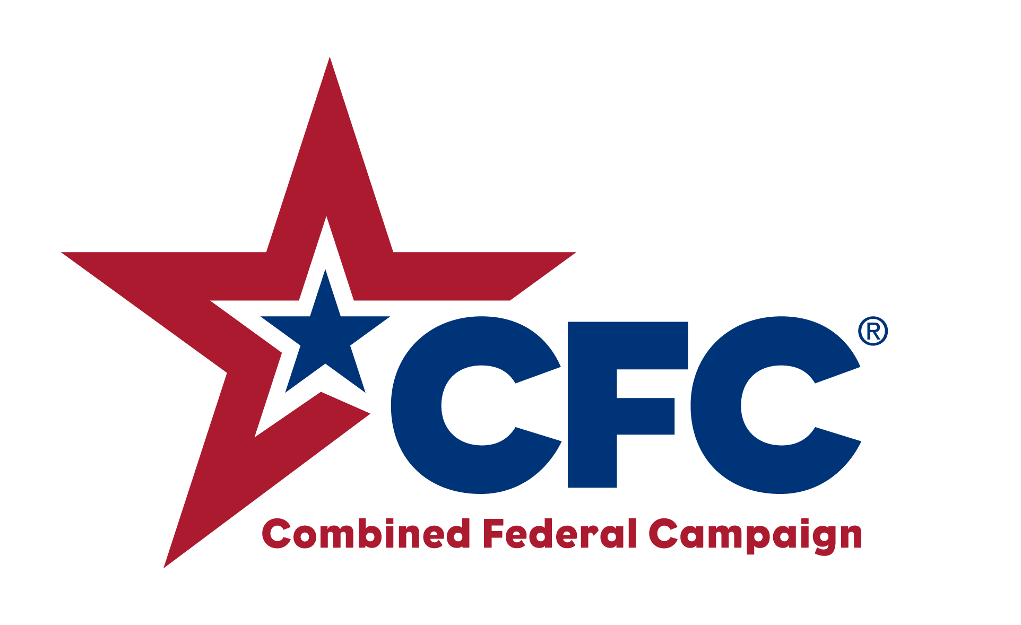

Northern Lights
COMBINED FEDERAL CAMPAIGN

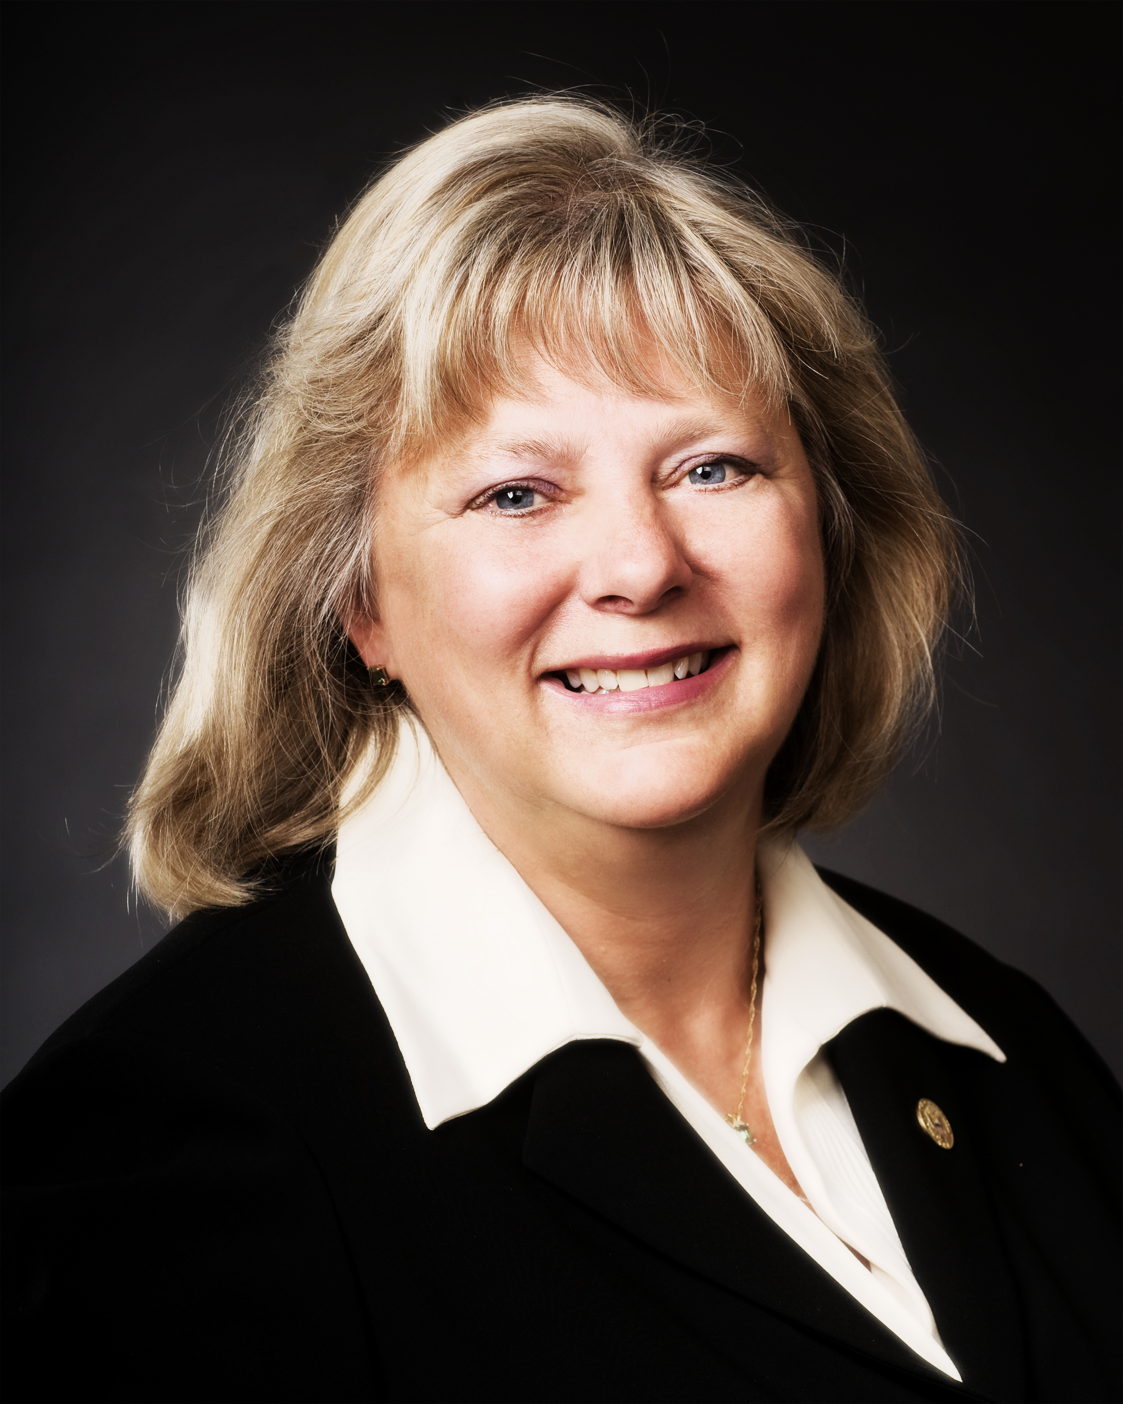 2016 Co-Chairs 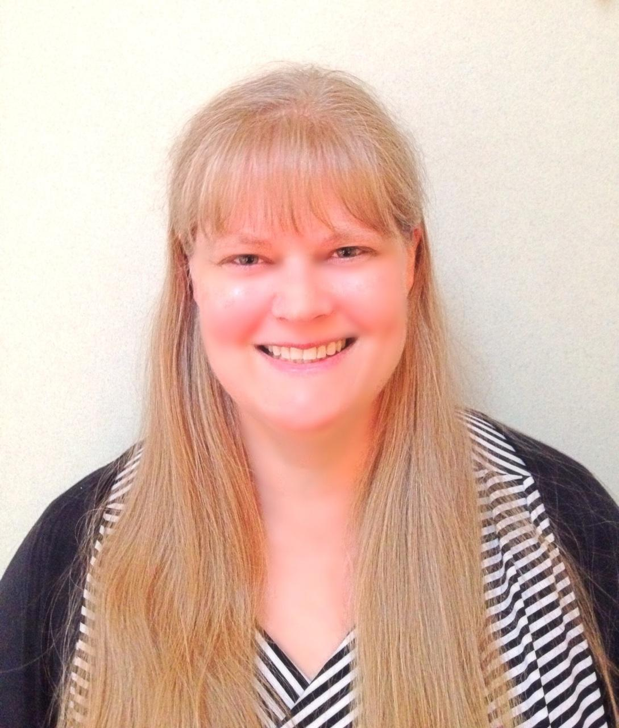

Diane D. Langer Caroline Peterson
FAA, Minneapolis Air Traffic USDA, Ames – Agricultural
Control Tower Research Service

Dear Federal Employees, Postal Staff and Military Personnel:

We return to our theme of You Can Change a Life for the 2016 Northern Lights Combined Federal Campaign. No matter the amount of your donation, it can make a large difference to the lives of those who receive the benefits. And who knows, perhaps it will also change your life as well. For example, $15/pay period provides backpacks and school supplies for 15 homeless children; $30/pay period provides 156 hot meals for older adults; $25 pays for school pictures for one homeless child; $100 provides 20 rides for a cancer patient for radiation and chemotherapy treatments. Think of how that changes their lives!

Each of you demonstrates daily through your government and military service how your ordinary efforts touch citizens’ lives and in ways that guarantee assistance, safety, and security. You also demonstrate your compassion through your support of the organizations in the CFC. Time and again, the generosity of federal employees is realized through this most successful of workplace giving campaigns.

In 2015, the employees in the Northern Lights area raised $720,000 for charities. These funds help the neediest in our communities, but also provide services that we all may need at any time. Our goal for the 2016 campaign is $1,000,000; this is a big jump, but a necessary one. Please join us to reach that goal and demonstrate the commitment of federal employees to both country and community.

